Solar Collector Design and Analysis using TracePro®
Analyze and Optimize Solar Collectors for both Direct
and Indirect Solar Contribution

Solar energy has reached the point of mass acceptance by consumers worldwide as a means
for producing energy and hot water at a competitive cost per watt and low carbon footprint. Solar cells,
solar farms, and solar collectors convert solar radiation into electrical power with efficiency of more than 40%
in mass-produced devices. The advances in materials, chemistry, and construction are among the many reasons for the increase in efficiency, but there are more gains to be had by using new optical devices. TracePro’s Solar Emulator and simulation and optimization capabilities have helped manufacturers achieve even greater efficiency by using optimized collector optics, thus dropping the cost per watt.
The first step for simulating a solar collector system
is setting the position of the solar device on the world map. TracePro’s Solar Emulator provides a set
of predefined city locations, as well as Google Maps positioning as shown in Figure 1. The next step
in the solar simulation process is to establish
the direct and indirect sun models to be used
as sources for the simulation. TracePro provides
built-in direct models and both the Igawa and the Darula and Kittler indirect sun contribution models. It also the capability to define turbidity conditions to calculate changing atmospheric conditions over time using user-defined time periods with sun tracking capability. This feature set makes TracePro an extremely valuable tool for any engineer calculating solar contribution.
TracePro’s Solar Emulator is the industry’s only tool
for analyzing 3D designs and simulating
performance-based, standardized definitions for geographical location (latitude, longitude, and elevation), period of sun travel with multi-axial tracking, and irradiance for both direct and indirect
sun contribution. Analysis output includes irradiance, candela maps, turbidity calculations, total flux, and efficiency on the target over time.
TracePro’s Solar Emulator and design, analysis, and optimization capabilities have been proven to accurately predict total energy output when solar collector systems are in real-world conditions. Currently, there are more than 350 research papers written by TracePro users detailing TracePro’s capabilities for designing solar collection systems.
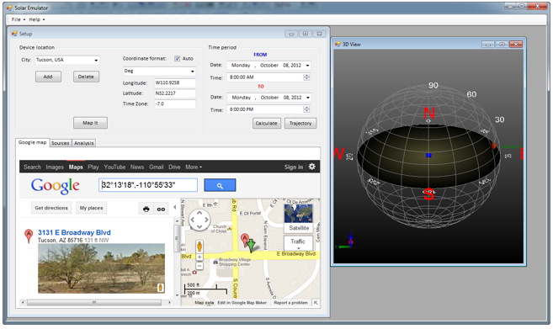
TracePro’s Solar Emulator and optimization features ensure solar collectors perform at peak efficiency.
Figure 1: Global positioning using Google Maps support
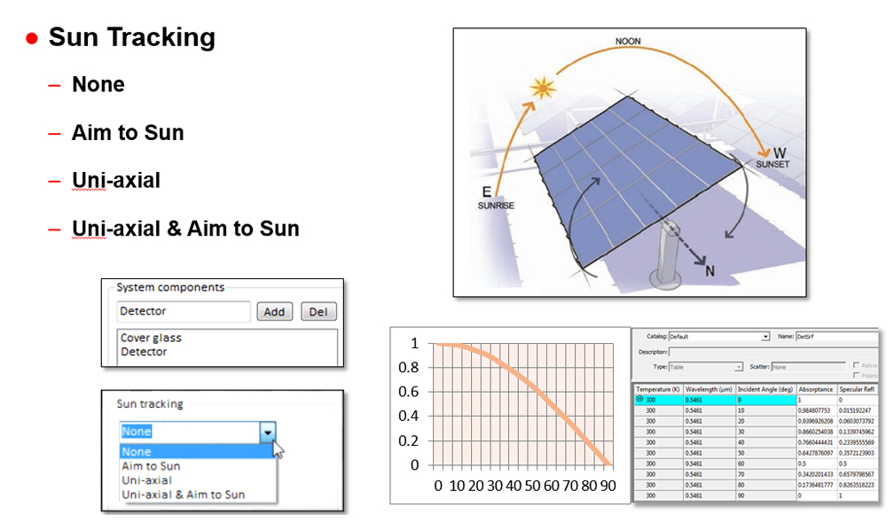
- Source modeling based on:
  - Direct and indirect solar radiation,
including atmospheric scattering
  - Latitude, longitude, and elevation
  - Date and time
  - User-selectable wavelengths
Figure 2: Sun tracking showing Aim to Sun calculations
over time for a standard photovoltaic panel.
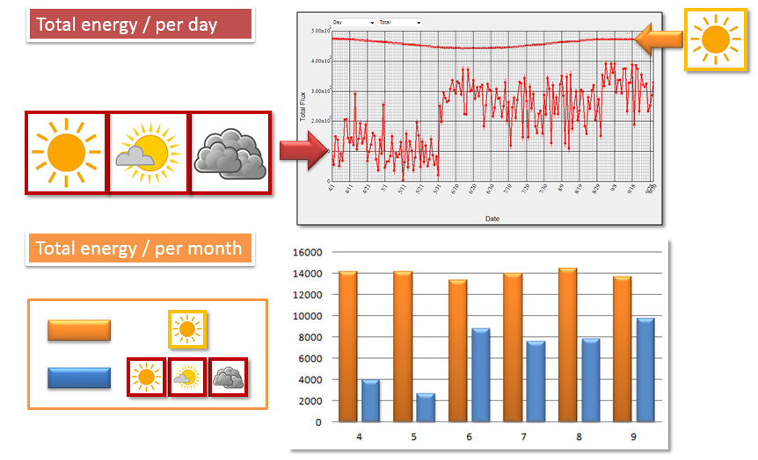
- User-defined parameters also include step intervals, wavelength, entrance pupil, solar irradiance, number of rays to be traced
Figure 3: Turbidity calculations are shown using sunny,
cloudy, and partly cloudy data for each monthly period. Bottom graphics shows full sunny condition in orange
versus turbidity contributions in blue.
- Irradiance and candela mapping
- Total collected energy reported in graphical
and tabular formats over calculated period
- Flux Report based upon sun position
- Sun Tracking
  - Aim to Sun
  - Uni-axial
  - Uni-axial coupled with Aim to Sun
- Global position
  - Predefined city list
  - Google Maps positioning
- Turbidity
  - Fully cloudy through sunny definitions specified per period

REV 2018-09-21
REV 3/15
Figure 2: Illuminance Map for Absorbed
Flux Observation

